**Mini Project II**

**<Safe Vehicle Driving With Eye Aspect Ratio>**

Version 1.0



**Institute of Engineering & Technology**

ManishYadav

(161500308)

Sahil Sharma

(161500473)

Shashi Kumar Verma

(161500507)

Supervised By

Mohd. Amir Khan

Technical Trainer

Department of Computer Engineering & Application

## Table of Contents

1. INTRODUCTION 1
   1. PURPOSE 1
   2. SCOPE 1
   3. DEFINITIONS, ACRONYMS, AND ABBREVIATIONS 2
   4. REFERENCES 2
   5. OVERVIEW 2
2. GENERAL DESCRIPTION 3
   1. PRODUCT PERSPECTIVE 3
   2. PRODUCT FUNCTIONS 3
   3. USER CHARACTERISTICS 4
   4. GENERAL CONSTRAINTS 4
3. SPECIFIC REQUIREMENTS 4
   1. EXTERNAL INTERFACE REQUIREMENTS 5
      1. *User Interfaces 5*
      2. *Hardware Interfaces 6*
      3. *Software Interfaces 6*
      4. *Communications Interfaces 7*
   2. FUNCTIONAL REQUIREMENTS 7
      1. *<Functional Requirement or Feature #1> 7*
      2. *<Functional Requirement or Feature #2> 7*
   3. USE CASES 8
      1. *Use Case #1 8*
      2. *Flowchart 9*
   4. Function *9*
   5. NON-FUNCTIONAL REQUIREMENTS 10
      1. *Performance 10*
      2. *Reliability 10*
      3. *Availability 10*
      4. *Security 10*
      5. *Maintainability 11*
      6. *Portability 11*
   6. INVERSE REQUIREMENTS 11
   7. DESIGN CONSTRAINTS 11
   8. LOGICAL DATABASE REQUIREMENTS 11

3.9 OTHER REQUIREMENTS...................................................................... ERROR! BOOKMARK NOT DEFINED.

1. ANALYSIS MODELS 11

4.1 ARCHITECTURE DIAGRAM................................................................ ERROR! BOOKMARK NOT DEFINED.

4. 2 DATA FLOW DIAGRAMS (DFD).......................................................... ERROR! BOOKMARK NOT DEFINED.

A. APPENDICES 13

ASSUMPTIONS AND DEPENDENCIES 13

# Introduction

In this Project we mainly provide the facility to the people who are driving car at night what we gonna do in this project is that we make a device in which we use camera through which we detect the increasing ratio of the person eye who are driving the car in the ratio is continuously increases per minute then we start the siren in the car so that the person slow down the car and safe from any tragedy.Accidents are the most common cause of death for the peoples who drive vehicles. Accidents happen, even to the people who are careful, but many accidents may be avoidable if simple precautions are taken. One of the major reasons for the accident is drink and drive. We can avoid these accidents by providing the eye blink and alcohol sensors to the drivers. The eye blink switch responds to the voluntary blink of the eye and requires minimal calibration. It discriminates between voluntary and involuntary blinks

## Purpose

The purpose of this project it to reduce the number of car accidents caused by drivers only the cases when they are sleeping. In other cases when the driver has been driving for hours or is waked up early for job, it creates again a gap for making an error. This error could cause his/her death as well as other people who are driving or passing by. So we aim to take that phone and make it look like a special device which will serve as a guard of the driver and give the driver the opportunity to be fully focused and have a high probability of avoiding any accidents. Moreover crash detection algorithm will be implemented to make emergency calls in case of car accident. This project involves controlling accident due to unconscious through Eye blink. Here one eye blink sensor is fixed in vehicle where if anybody looses conscious and indicate through alarm. The Objective of this project is to develop a system to keep the vehicle secure and protect it by the occupation of the intruders.

## Scope

The future works may focus on the utilization of outer factors such as vehicle states, sleeping hours, weather conditions, mechanical data, etc, for fatigue

measurement. Safe Vehicle Driving With Eye Aspect Ratio pose a major threat to highway safety, and the problem is particularly severe for commercial motor vehicle operators. Twenty-four hour operations, high annual mileage, exposure to challenging environmental conditions, and demanding work schedules all contribute to this serious safety issue. Monitoring the driver’s state of Eye blinking and vigilance and providing feedback on their condition so that they can take appropriate action is one crucial step in a series of preventive measures necessary to address this problem. Currently there is not adjustment in zoom or direction of the camera during operation. Future work may be to automatically zoom in on the eyes once they are localized.

## Definitions, Acronyms, and Abbreviations

Eye blink is defined as a rapid closing and reopening of eyelids, and it typically lasts from 100 to 400 ms Previous methods for eye blink detection estimate eye state as either open or closed or track eye closure events.

## References

This subsection should:

(1) [https://www.seminarsonly.com](https://www.seminarsonly.com/) (2)<https://www.mdpi.com/2078-2489/9/4/93/htm>

(3) https://[www.pyimagesearch.com/](http://www.pyimagesearch.com/)

This information may be provided by reference to an appendix or to another document.

## Overview

Eye blink detection is one of the important problems in computer vision. It has many applications such as face live detection and driver fatigue analysis. The existing methods towards eye blink detection can be roughly divided into two categories: contour template based and appearance based method.

# General Description

There are several different algorithms and methods for eye tracking, and monitoring. Most of them in some way relate to features of the eye (typically reflections from the eye) within a video image of the driver. The original aim of this project was to use the retinal reflection as a means to finding the eyes on the face, and then using the absence of this reflection as a way of detecting when the eyes are closed. Applying this algorithm on consecutive video frames may aid in the calculation of eye closure period.Eye closure period for drowsy drivers are longer than normal blinking. It is also very little longer time could result in severe crash. So we will warn the driver as soon as closed eye is detected.

## Product Perspective

This project is based on image recognition feature .It will check whether if he/she might be sleeping. If it will be the case so, then the phone will interact with a driver, to wake him/her up. The type of interaction might be an alarm with vibration or a customized message set by the driver itself with maximum volume enabled.

This application will execute the commands according to the user request. The following commands will be implemented:

Eye detection Send a message

Read out incoming notifications

## Product Functions

Drivers will be the main users and targets of Safe Vehicle Driving With Eye Aspect Ratio Project:

* + - Driver must be alerted or warned when systems detect that he/she is sleeping using Eye Detection algorithm.
    - Driver must be able to ask for emergency call when Car crash detected.

## User Characteristics

Software team needs to provide a simple and user friendly interface that is easy to cope with. A mid level phone user must comprehend the system just with reading simple instruction manual about command list. Command list should not be very complex. An average user should easily understand and memorize commands. A user with small speaking flaws must be tolerated by the system.

## General Constraints

In this section of SRS document, general description of the factors which influences the system and its requirement is involved. It supplies with diagrams and models which gives a view of how the Safe Vehicle Driving With Eye Aspect Ratio Project system is going to behave, respond and interact with the customer.

# Limitations:-

The limitations of the system are as follows. 1.Dependence on ambient light:-

With poor lighting conditions even though face is easily detected, sometimes the system is unable to detect the eyes. So it gives an erroneous result which must be taken care of. In real time scenario infrared backlights should be used to avoid poor lighting conditions.

1. Optimum range required:-When the distance between face and webcam is not at optimum range then certain problems are arising.When face is away from the webcam (more than 70cm) then the backlight is insufficient to illuminate the face properly. So eyes are not detected with high accuracy which shows error in detection of Eye blinking.

This issue is not seriously taken into account as in real time scenario the distance between drivers face and webcam doesn’t exceed 50cm. so the problem never arises.

# Specific Requirements

## External Interface Requirements

## User Interfaces

* Eye Detection:

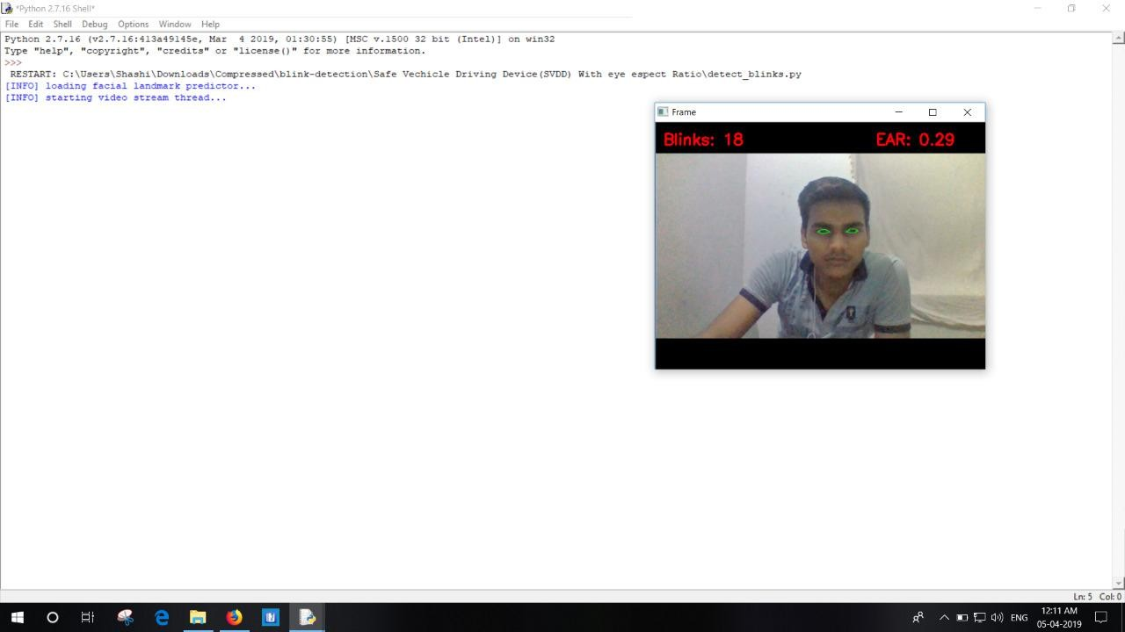

Android app :

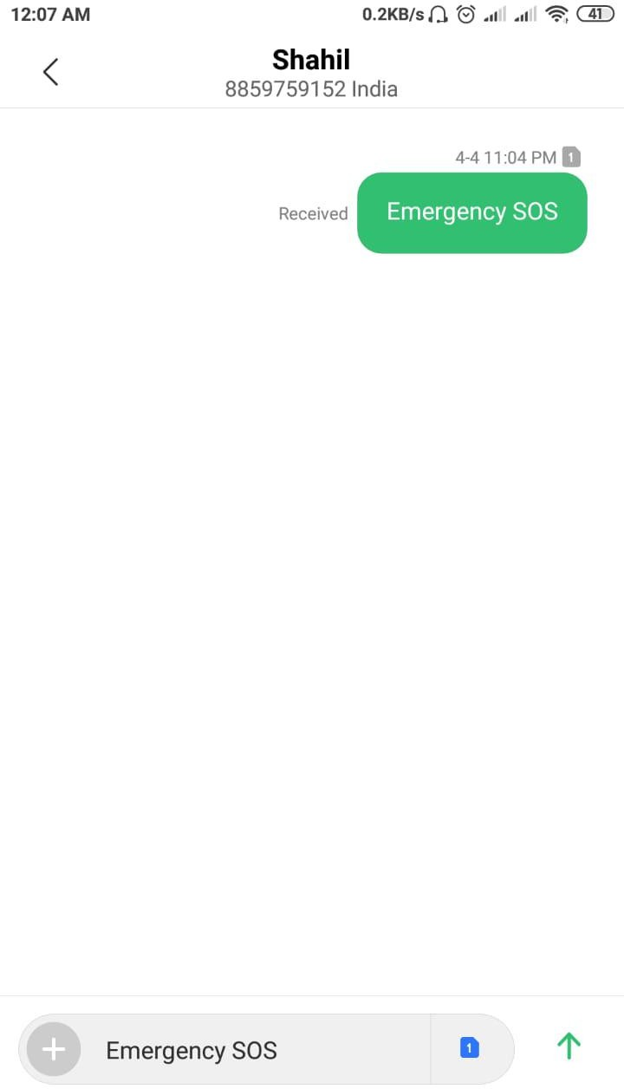

:

## Hardware Interfaces

* This application will require a smartphone
* Ardino
* Camera
* Motor
* Motor Drive module
* Serial Communication

# Software Interfaces:

* Python
* Open CV(module)
* Firebase (Real Time database)

## Communications Interfaces

Internet connection with an average net speed is required to run this application smoothly.

## Functional Requirements

The system will perform the following functional requirements

* User can enable and disable Eye Detection System
* User can interact with Eye Detection System
* User can handle an incoming message
* User can acquire device status

## <Functional Requirement or Feature #1>Eye Detection

* + 1. **<Functional Requirement or Feature #2>Notification on Android app**
    2. **Block Diagram**

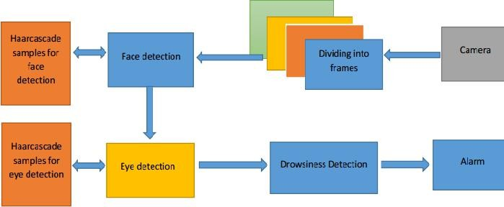

# Use Cases

## Use Case #1

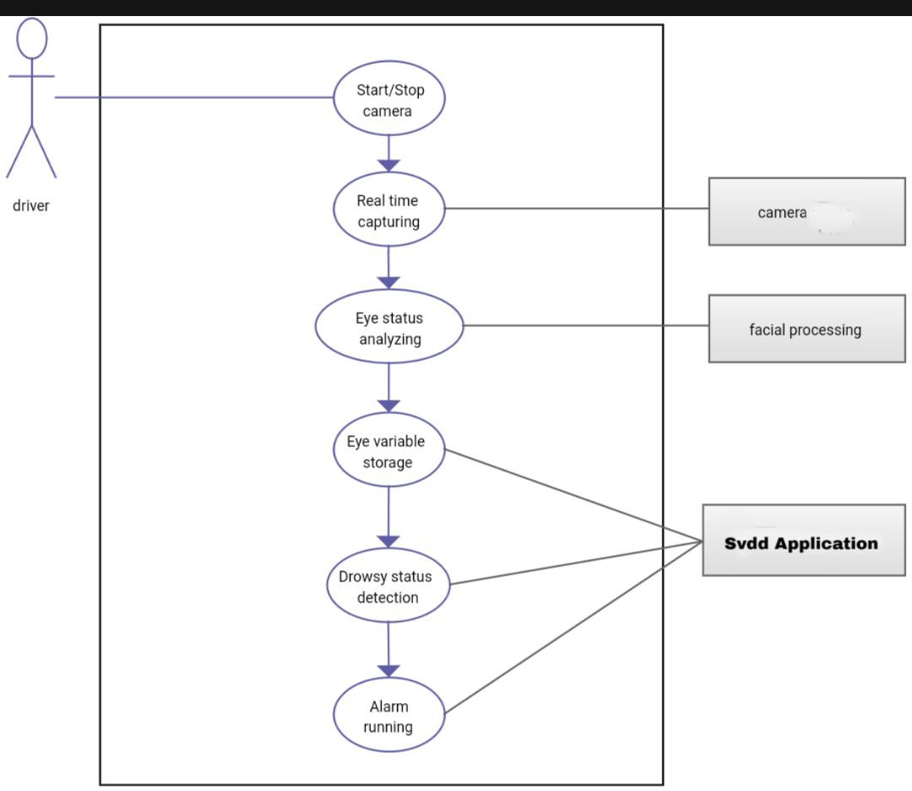

* + 1. **Flowchart**

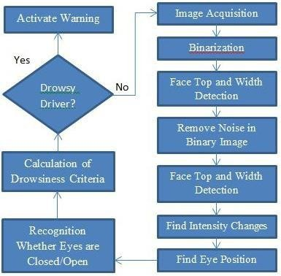

# Function:

When Eye blinking level exceeds a certain limit then a signal is generated which is communicated to the relay through the parallel port(parallel data transfer required for faster results).The relay drives the on delay timer and this timer in turn runs the stepper motor for a definite time period .The stepper motor is connected to a linear actuator.

The linear actuator converts rotational movement of stepper motor to linear motion. This linear motion is used to drive a shaft which is directly connected to the hydraulic braking system of the vehicle. When the shaft moves it applies the brake and the vehicle speed decreases.

Currently there is not adjustment in zoom or direction of the camera during operation. Future work may be to automatically zoom in on the eyes once they are localized. This would avoid the trade-off between having a wide field of view in order to locate the eyes, and a narrow view in order to detect fatigue.

This system only looks at the number of consecutive frames where the eyes are closed. At that point it may be too late to issue the warning. By studying eye movement patterns, it is possible to find a method to generate the warning sooner. Using 3D images is another possibility in finding the eyes. The eyes are the deepest part of a 3D image, and this maybe a more robust way of localizing the eyes. Adaptive binarization is an addition that can help make the system more robust. This may also eliminate the need for the noise removal function, cutting down the computations needed to find the eyes. This will also allow adaptability to changes in ambient light. The system does not work for dark skinned individuals. This can be corrected by having an adaptive light source. The adaptive light source would measure the amount of light being reflected back. If little light is being reflected, the intensity of the light is increased. Darker skinned individual need much more light, so that when the binary image is constructed, the face is white, and the background is black.

## Non-Functional Requirements

## Performance

The performance requirements of Smart Driver Assistant are the following:

* It should process the Eye Detection algorithm less than 0.3 second

➢

## Reliability

* Smart Driver Assistant shall be run properly at every time needed.
* Failure intensity should not be acceptable.

## Availability

* Recovery of the whole system should take minimum time.
* Eye Detection message facility shall be implemented so that application crashes will be minimum.

## Security

* User also need to activate notification access permission on device manually .
* User's personal info shall not be accessed or reached by anyone except that person who can learn user location in case of emergency.

## Maintainability

* System shall responds to the real time and physical interactions.
* Codes shall be supported by some techniques like related implementation comments, naming conventions and coding standards for increasing readability for future developments.

## Portability

The Application shall be accessed also by different electronic devices using Android Operation System

The Application shall be working properly on different versions of Android Operation System

## Inverse Requirements

*State any *useful* inverse requirements.*

## Design Constraints

The design constraints of the are listed as below:

* The program will be implemented using Android studio.
* Database side will be implemented using Google Real time database Firebase.
* Minimum Android API level must be higher than User private data and actions must be kept private.

## Logical Database Requirements

Reeal time database Firebase.

## Other Requirement

No other requirement

# Analysis Models

## 4.1 Data Flow Diagrams (DFD)

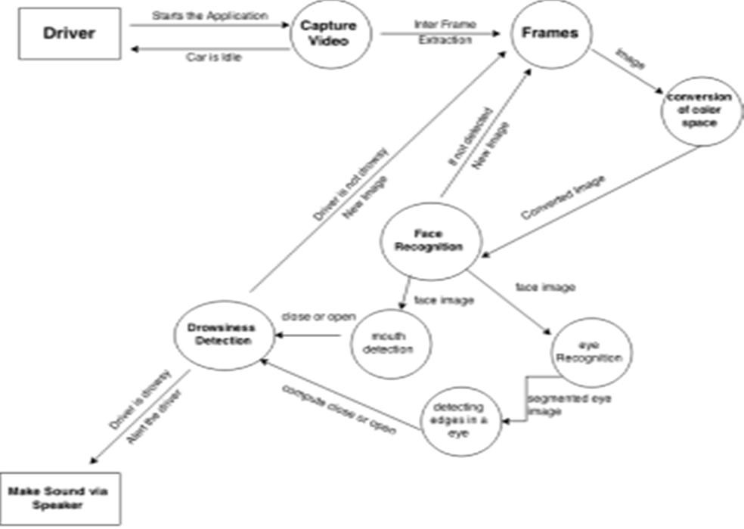

**4.4 Archtecture Diagram**

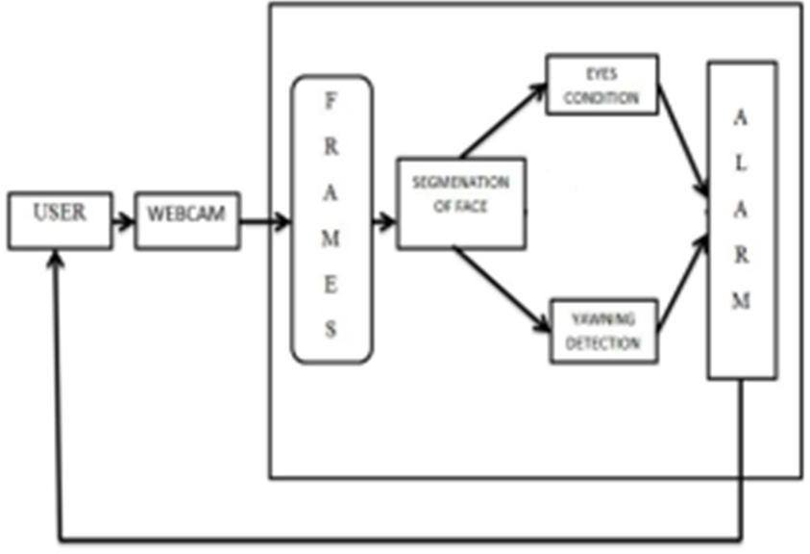

**A.** **Appendices**

**Assumptions and Dependencies**

Performance of driver eye detection will be highly diminished in complete dark places. So our product must not be used in complete dark environment for this purpose.It is assumed that there will be no broken bicycles which might be inappropriately shown in the User Interface.There must be at least one maintainer during the working time in each station.There must be a clone copy saved in case of System and Database crash.